Q1:
%% Second Order Impulse Response Plot

clear; clc; close all;

% HW Parameters
w_0 = 1;
alphas = [0, 0.2, 1, 5];
numerator = 1;

%% Calculate Four Impulse Responses
% Empty Plot
figure();
hold on;

% Our function is 1/(s^2 + 2 * alpha + w_0^2)
% So, our denominator coefficients are: 1, 2 * alpha, w_0^2

for i = 1:length(alphas)
alpha = alphas(i);
denominator = [1 2*alpha w_0^2];
H = tf(numerator, denominator); % tf creates a transfer function from our numerator and denominator.
impulse(H); % takes the impulse of our tf
end

xlabel('time (s)');
ylabel('Amplitude');
title('Impulse Response for Second-Order Systems');
axis([0, 50, -1, 1]);
legend('\alpha = 0', '\alpha = 0.2', '\alpha = 1', '\alpha = 5');
grid on;
hold off;

%% Calculate Step Responses
% Empty Plot 2
figure(2);
hold on;

for i = 1:length(alphas)
alpha = alphas(i);
denominator = [1 2*alpha w_0^2];
H = tf(numerator, denominator);
step(H); % takes the step of our tf
end

xlabel('time (s)');
ylabel('Amplitude');
title('2nd Order Step Response');
axis([0, 50, -1, 2])
legend('\alpha = 0', '\alpha = 0.2', '\alpha = 1', '\alpha = 5');
grid on;
hold off;
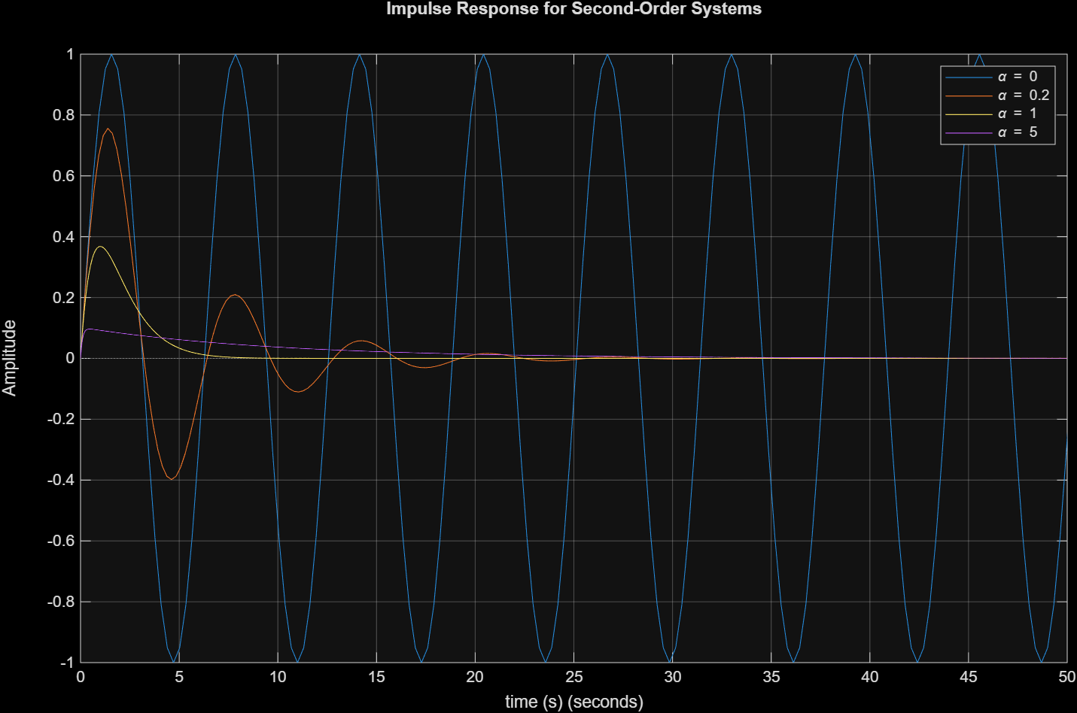
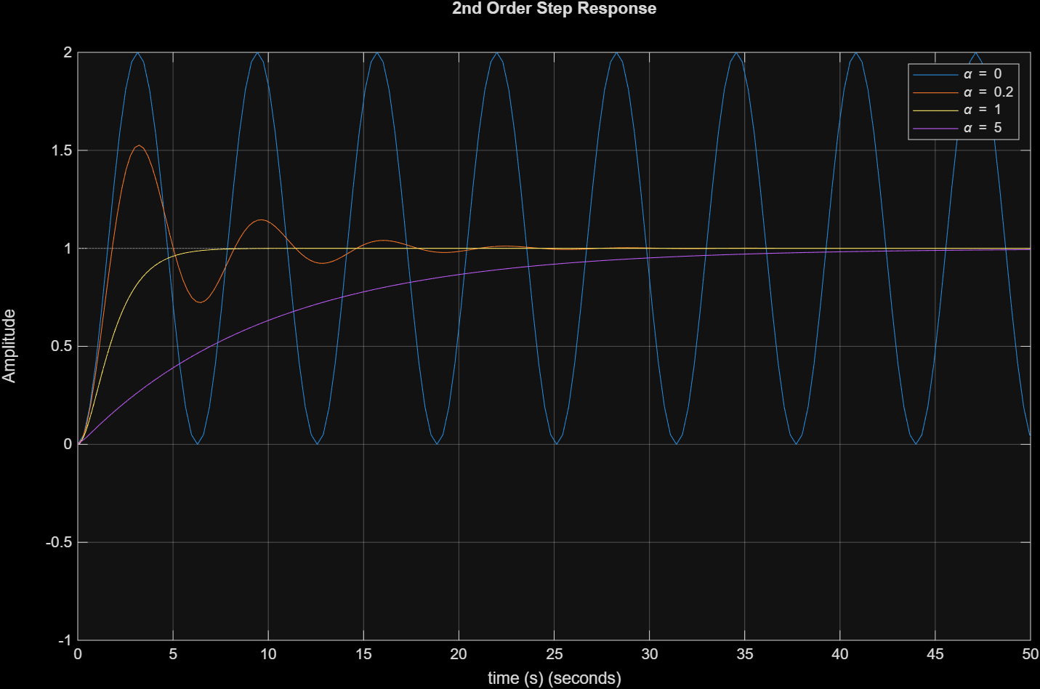

Q2:

%% Delayed Unit Step Response

clear; clc; close all;

% HW Parameters
w_0 = 1;
alpha = 0.2*w_0;
dt = 0.1;
a = 5;

t = 0:dt:50;
w_d = sqrt(w_0^2 - alpha^2);

% Unit Step
u = double(t >= a);

% Impulse Response
h = (1/w_d)*exp(-alpha*t).*sin(w_d*t);

% Exact Response
x_exact = zeros(size(t));
tau = t-a;
idx = t >= a;

x_exact(idx) = (1/w_0^2)*(1 - exp(-alpha*tau(idx)) .* (cos(w_d*tau(idx)) + (alpha/w_d)*sin(w_d*tau(idx))));

% Numerical Response
x = conv(u,h)*dt;
x_numerical = x(1:length(t));

% Plot
figure;
plot(t,u,t,x_exact,t,x_numerical);
xlabel('Time (s)');
ylabel('Amplitude');
title('Delayed Unit Step Response');
legend('u(t-a)','x exact','x numerical');
axis([0 50 0 2]);
grid on;

